Visiting (Multiple Entry) Visa − F6B

F6B − Visiting (Multiple Entry) Visa is to visit Nigeria for the purpose of social visit to family and friends

##### Eligibility

Citizens of countries who offer similar multiple entry visa to Nigerian citizens

##### Requirements

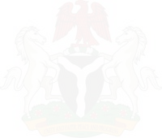

1. Passport/Travel Document NOT less than 6 months validity period.Must have two blank facing pages.Non-US passport holders MUST provide Residency Status in the U.S e.g. Green Card, Student Visa or Work Visa
2. Application and payment online at <https://visa.immigration.gov.ng/> . This MUST be printed for submission
3. Invitation letter from family/friend in Nigeria attached with copy of Nigerian Passport data page OR copy of residence permit
4. Evidence of sufficient fund (Recent Bank Statemet)
5. Flight Itenerary showing Return ticket
6. Evidence of Hotel Reservation **OR** host address in Nigeria indicated in Invitation Letter listed above.